**NATIONAL COLLEGE OF IRELAND**

**CA1**

**FUNDAMENTALS OF BUSINESS ANALYSIS**

**BSHC2 & BSHBIS2**

Circulated: 5th October 2017

Deadline for submitting assignment: 11pm on 17th November 2017

Credit: 35%

**You are required to do a group project of at least 2,000 words per person, which accounts for 50% of your overall mark.**

National College of Ireland has decided to redevelop its **website and student portal** and it has approached you, and asked for you to **complete a Requirements Elicitation** for this project.

Using **at least 4 different Elicitation Techniques**, you must produce a report of your findings.

This document will serve as the foundation for the solution to the website and portal redevelopment.

Your report should include (but does not have to be limited to):

* A project introduction
* An overview of the techniques that you have chosen
* A summary of the activities involved in eliciting the requirements using the chosen techniques
* A documentation of the results of your elicitation
* An analysis of the results
* Specification of the proposed solution

**NOTES:**

* This is a GROUP Project. Groups of 3 or 4 people will be formed in Class on Week 4.
* Please read the **Grading Rubric** supplied for further information on the Marking Scheme.
* The use of online **collaboration tools is recommended**. At a minimum, a tool for file sharing and a tool for communicating should be used.
* Some additional research/reading is required as part of your project. Your project should include **references detailing any Internet sites, books, or other sources that you have referred to in creating your report**.
* Your report must be submitted on Moodle by the due date (only Team Captain can submit on Moodle).
* The **“Peer Evaluation” form** must be uploaded to the Peer Evaluation Upload facility on Moodle by each group member. **Failure to do so, will result in a Zero grade for the entire project for that student.**
* Use the Harvard System of referencing in your text.
* Include a competent reference list in your project
* Plagiarism is viewed seriously by the NCI and could lead to your project receiving a NG (No Grade) and/or removal from the programme.

**Late projects will be penalised:**

A late submission point will become available on Moodle after the due date has passed.

In the case of an extension not being requested, not being granted or being exceeded, the following penalties apply to each piece of coursework:

* Up to one week late from the time and date of submission 10% of the mark awarded for the essay/project will be deducted.
* For every week after the first week and up to the sixth a further 5% will be deducted from the mark awarded.
* Any coursework received after a six-week period will attain a zero mark.

Example Requirement reports:

Example 1:

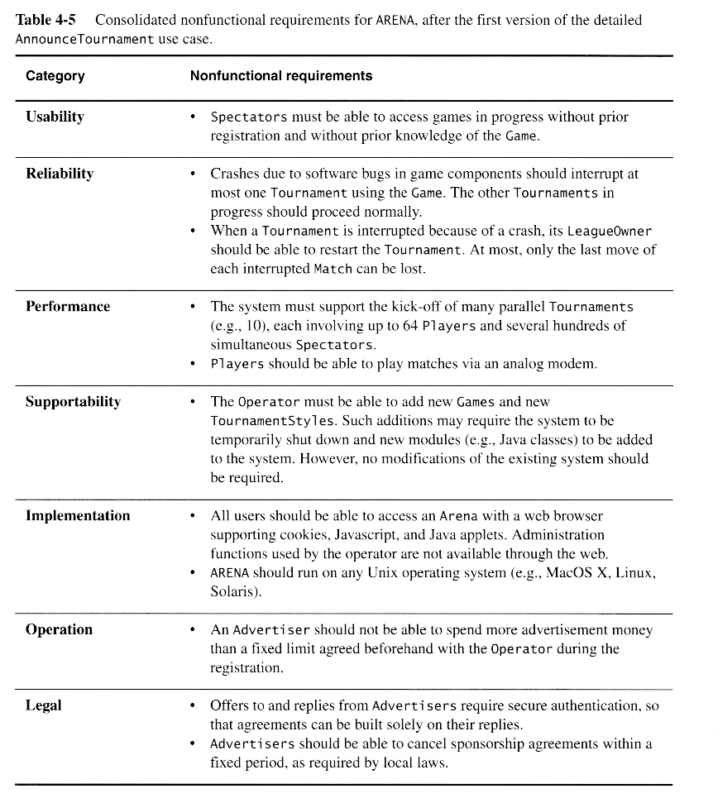

Example 2:

<https://arxiv.org/ftp/arxiv/papers/1305/1305.3255.pdf>